**Exercise 1: Configuring a Basic Spring Application**

**Scenario:**

Your company is developing a web application for managing a library. You need to use the Spring Framework to handle the backend operations.

**Steps:**

1. Set Up a Spring Project
2. Configure the Application Context
3. Define Service and Repository Classes
4. Run the Application

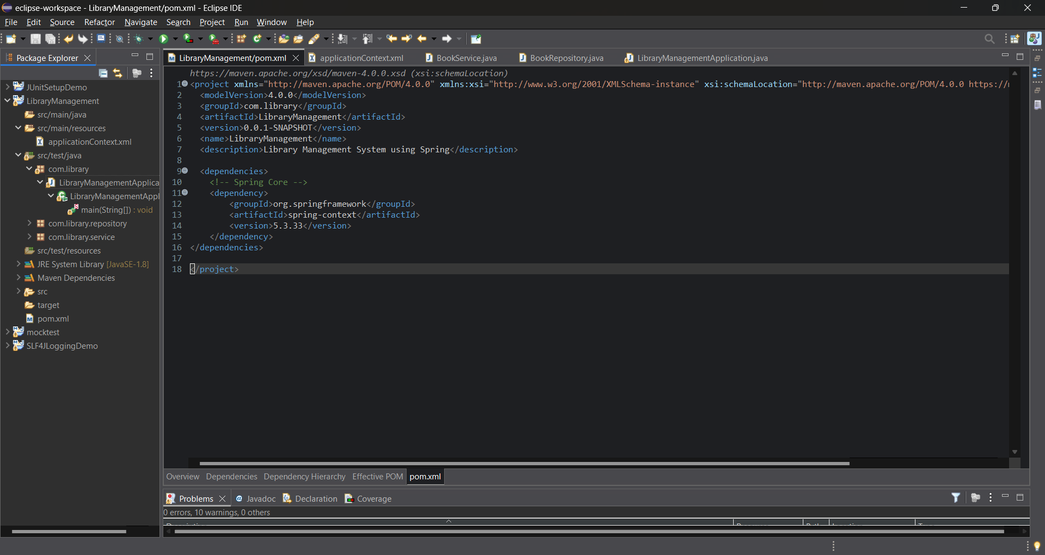

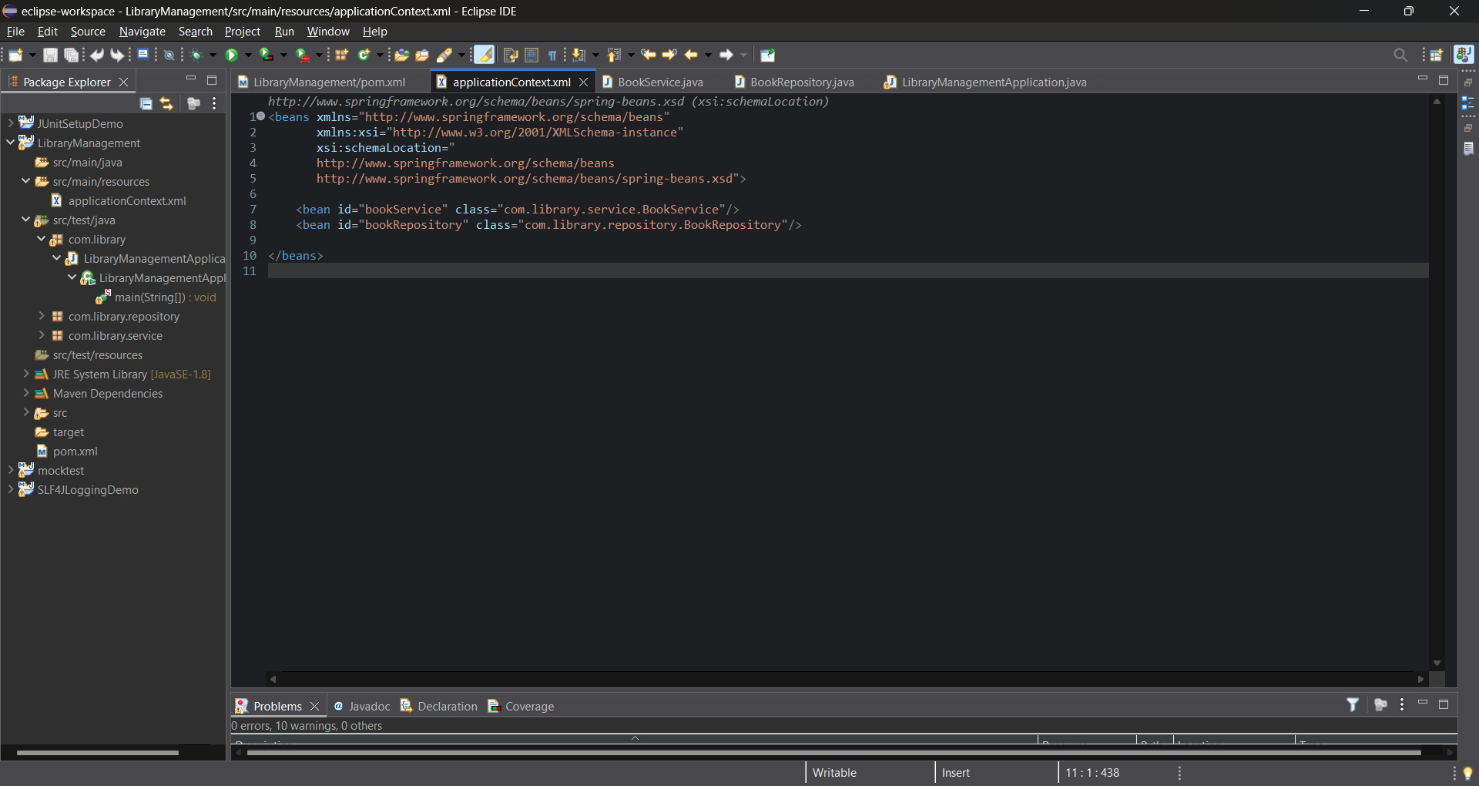

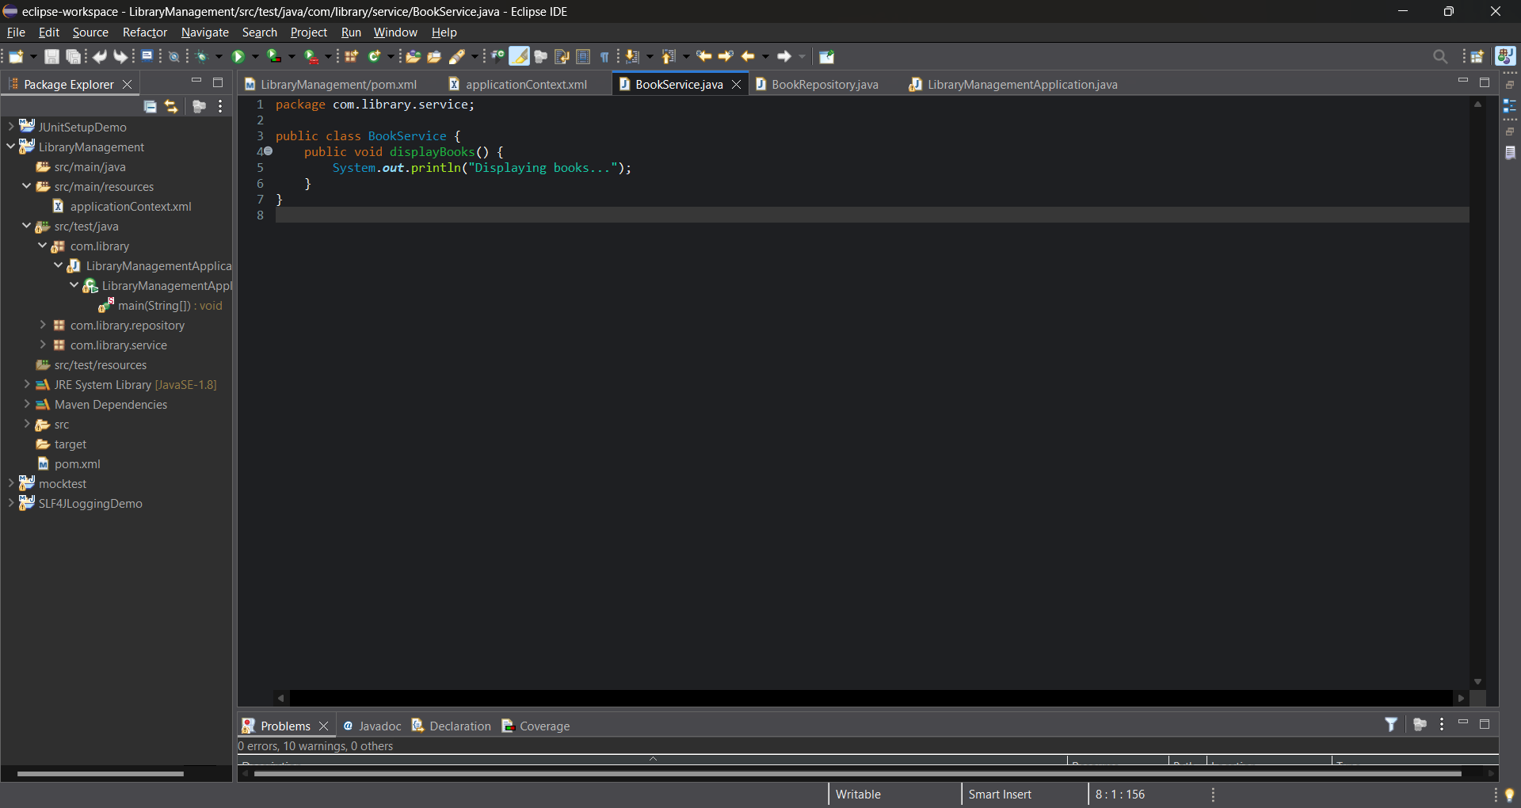

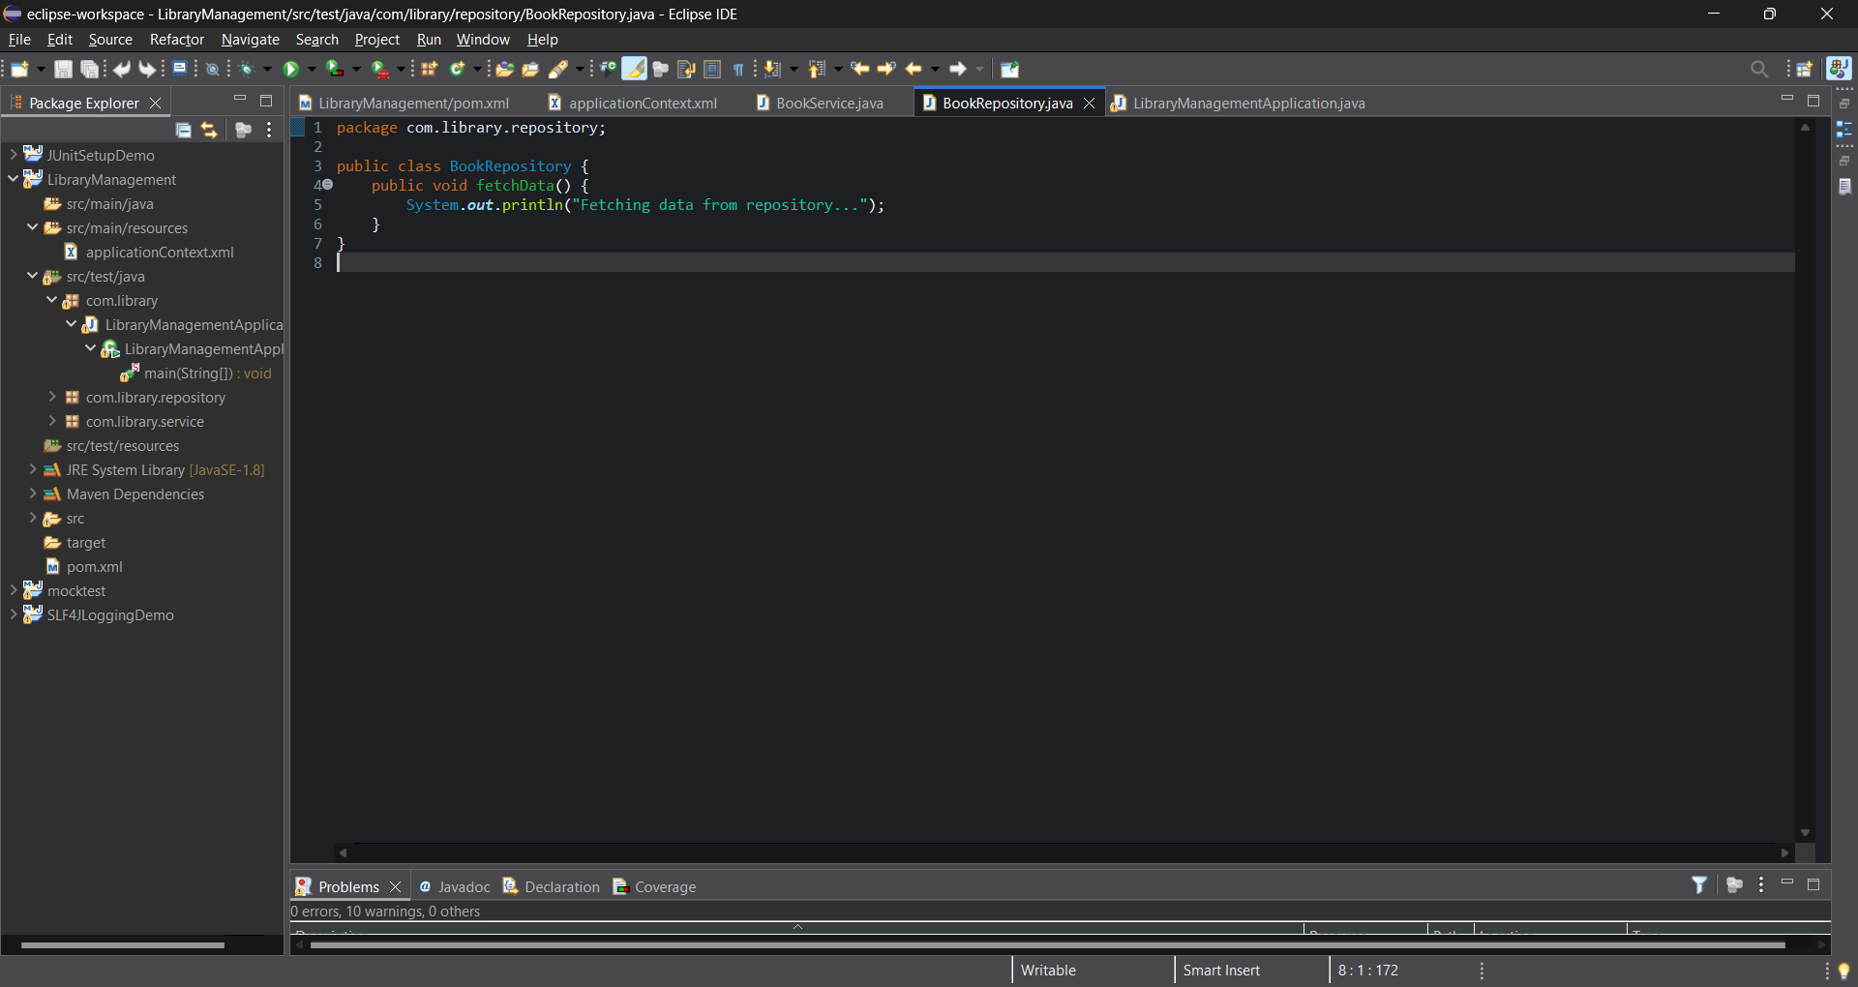

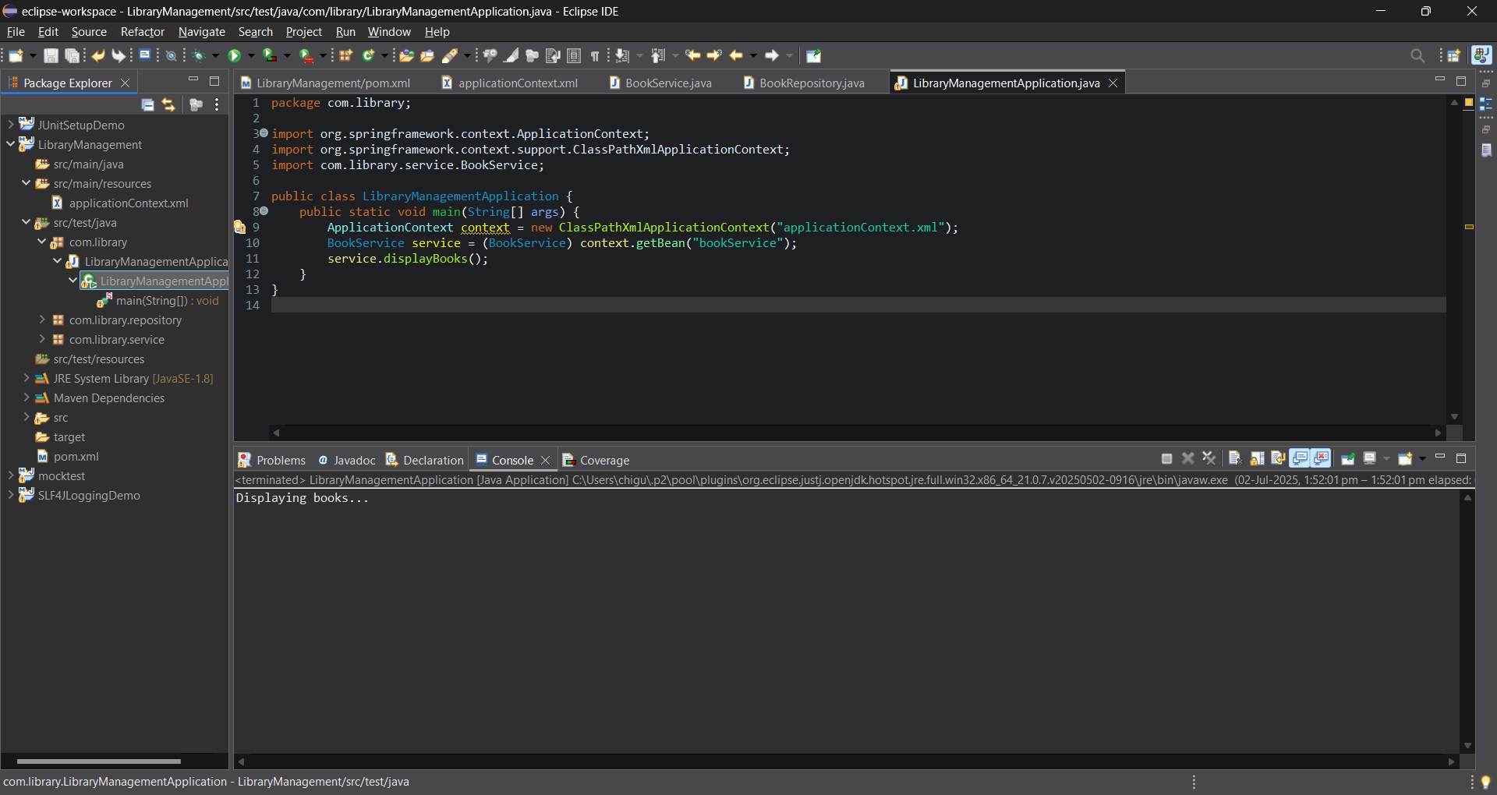

**Exercise 2: Implementing Dependency Injection**

**Scenario:**

In the library management application, you need to manage the dependencies between the BookService and BookRepository classes using Spring's IoC and DI.

**Steps:**

1. Modify the XML Configuration
2. Update the BookService Class
3. Test the Configuration

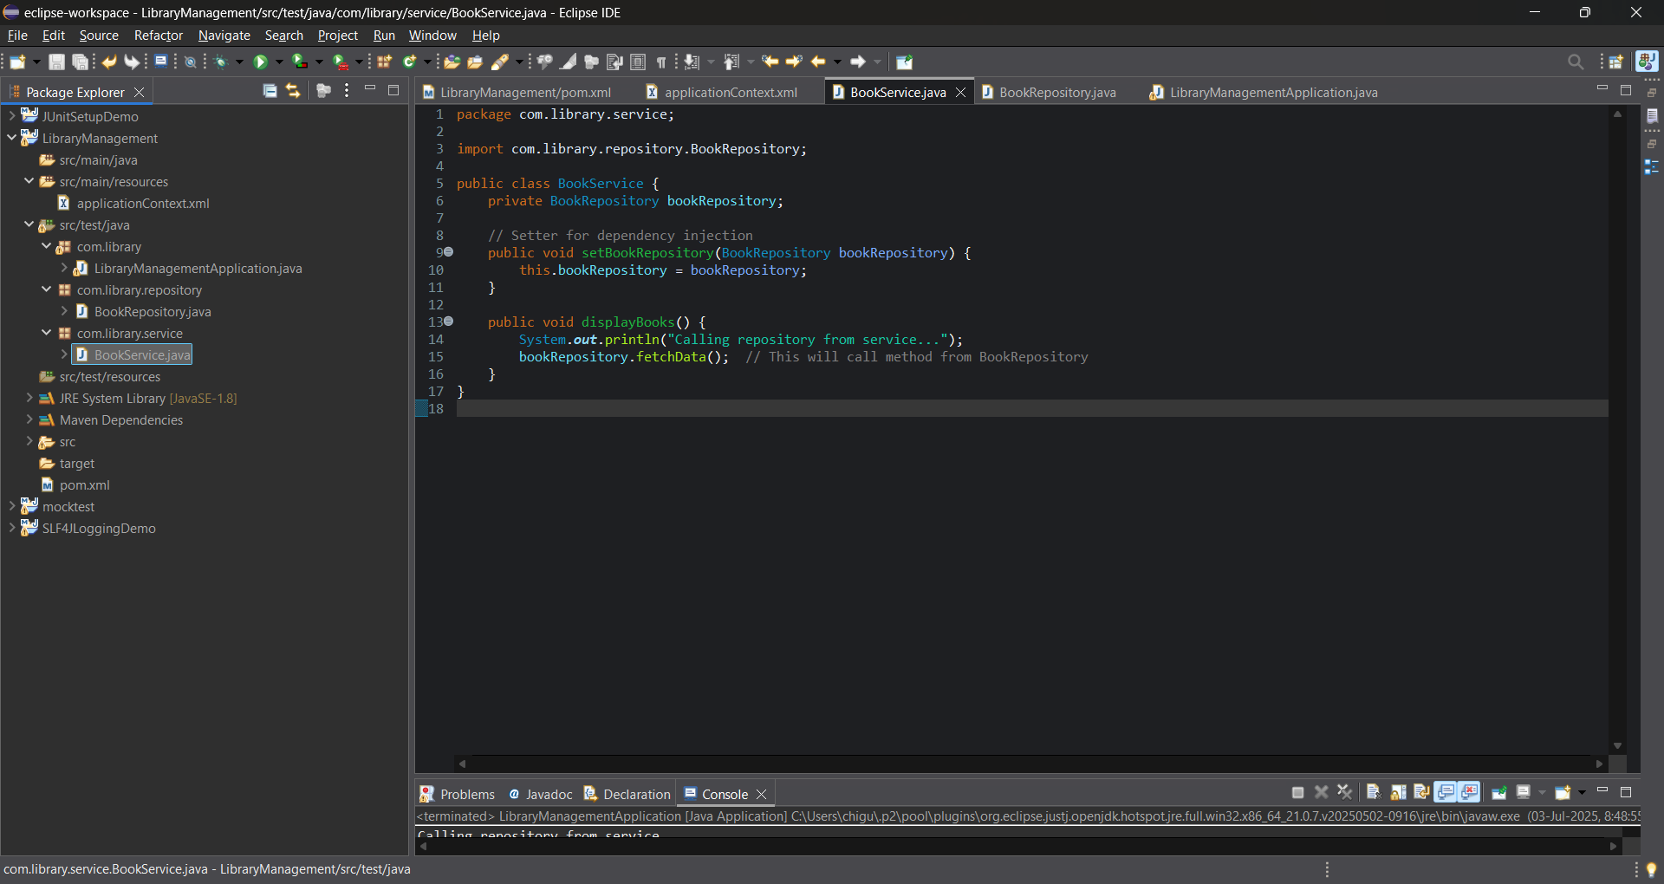

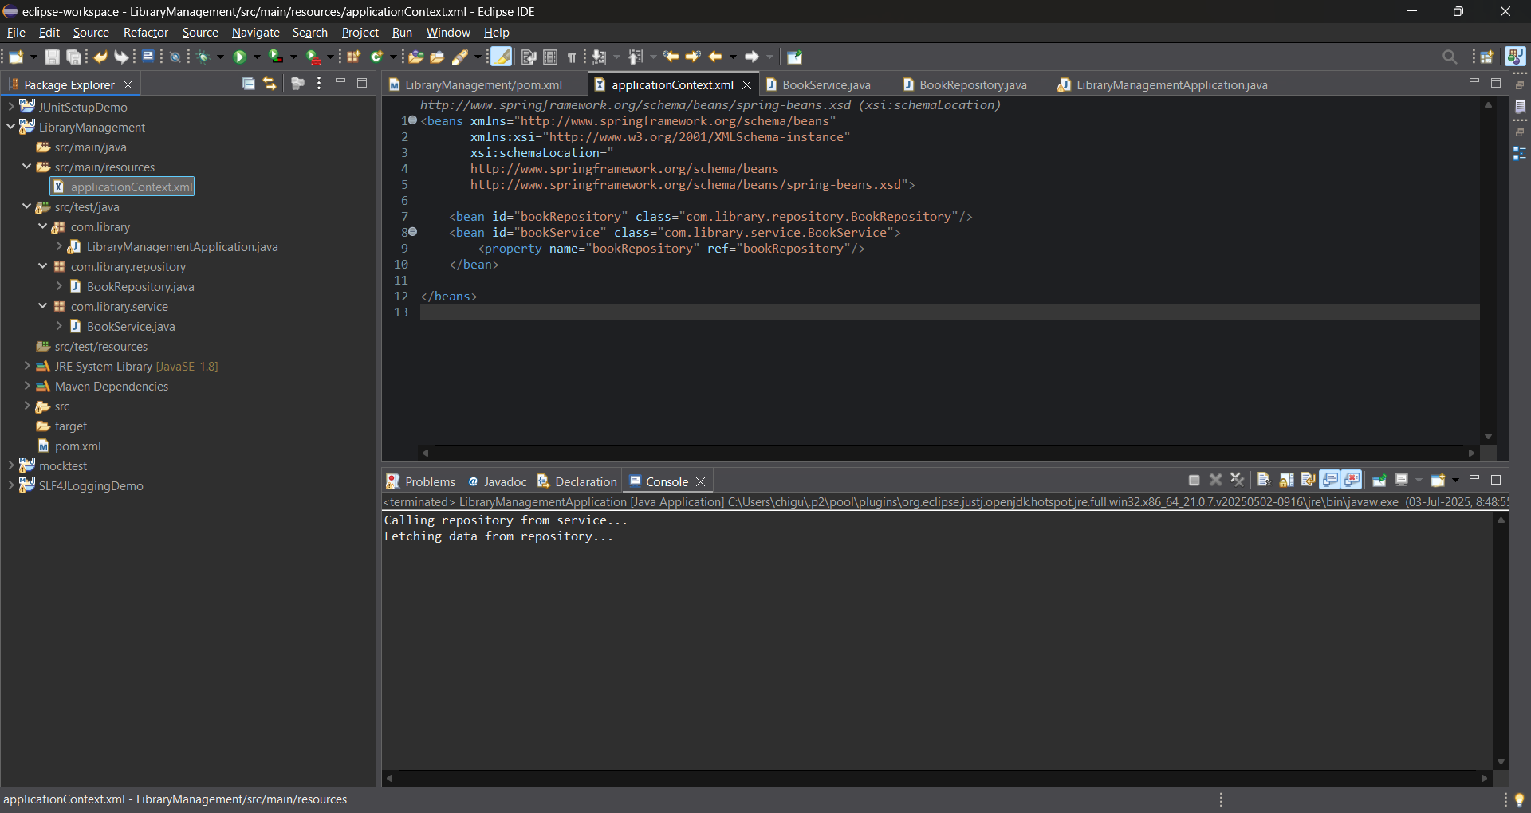

**Exercise 3: Implementing Logging with Spring AOP**

**Scenario:**

The library management application requires logging capabilities to track method execution times.

**Steps:**

1. Add Spring AOP Dependency
2. Create an Aspect for Logging
3. Enable AspectJ Support
4. Test the Aspect

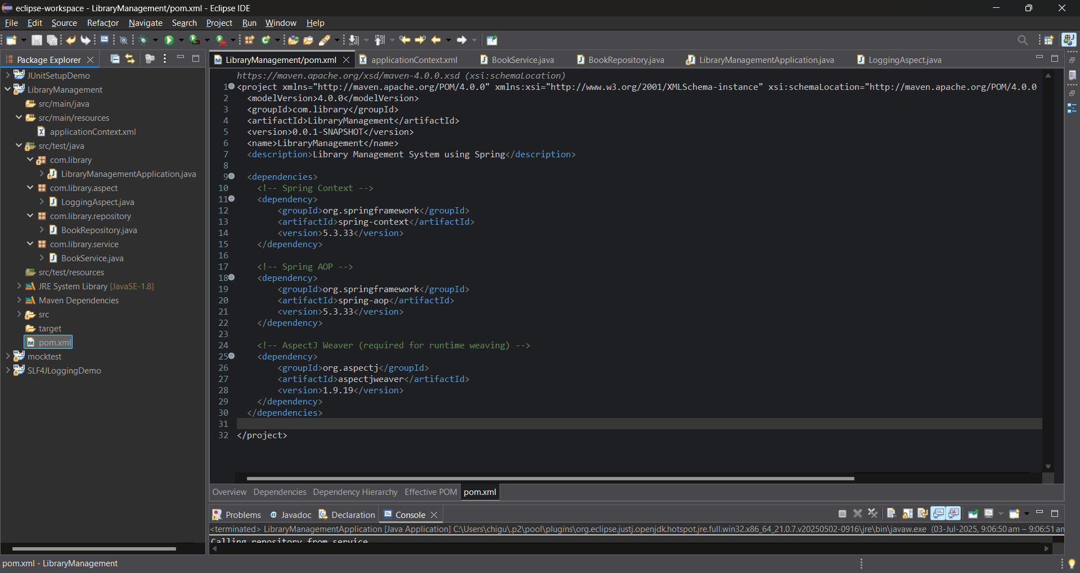

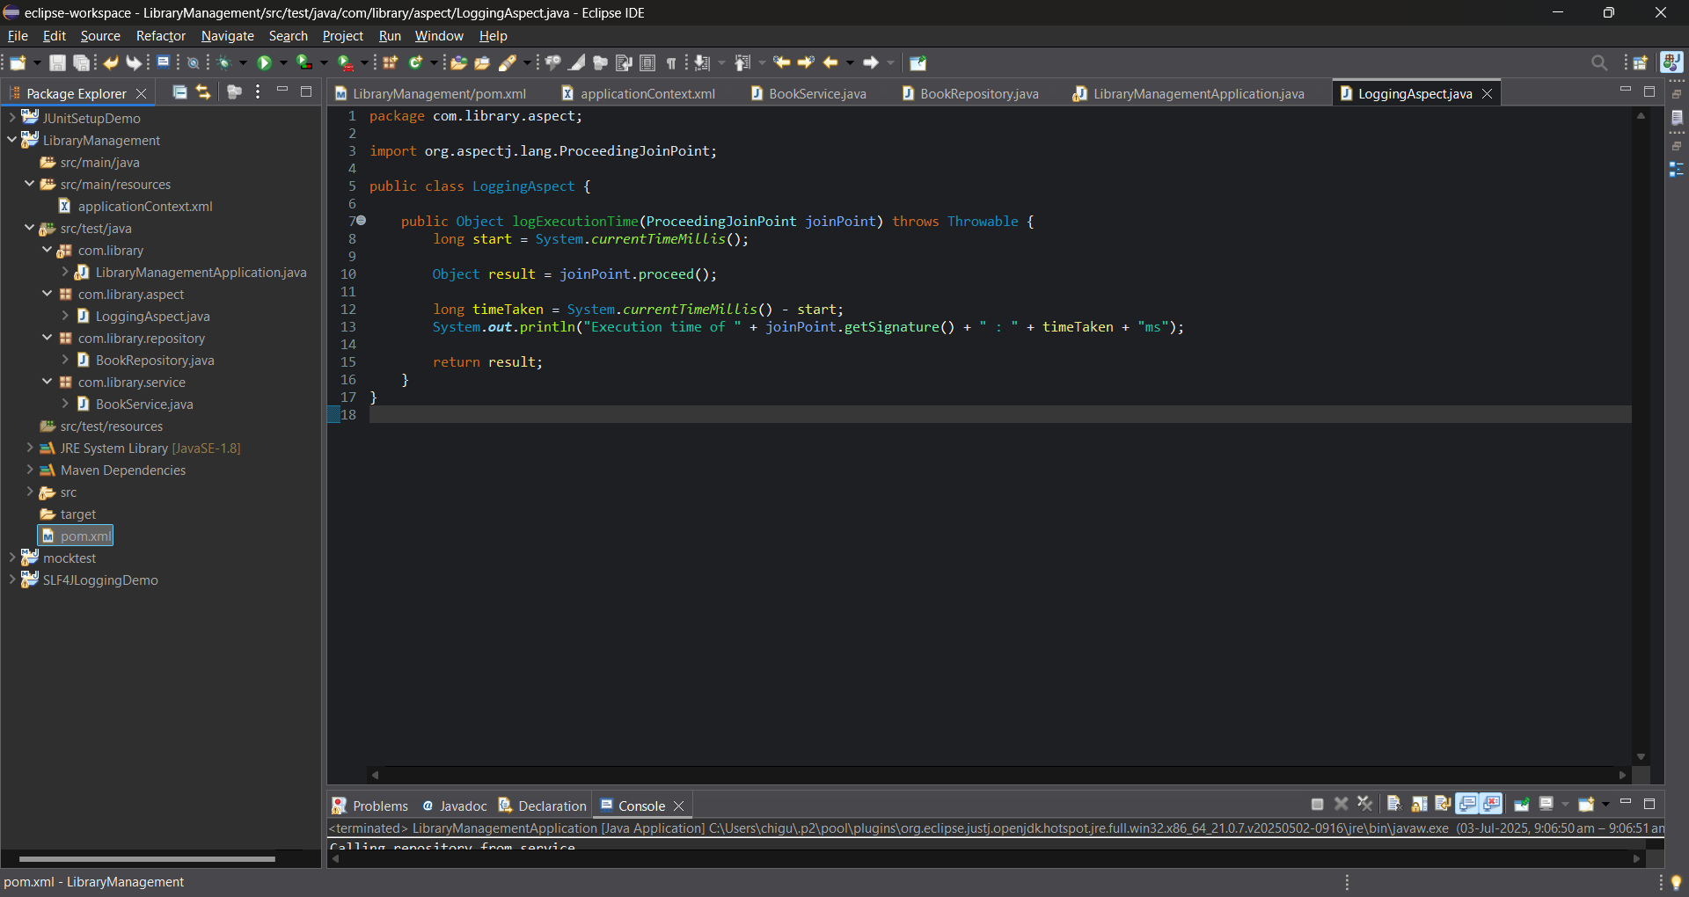

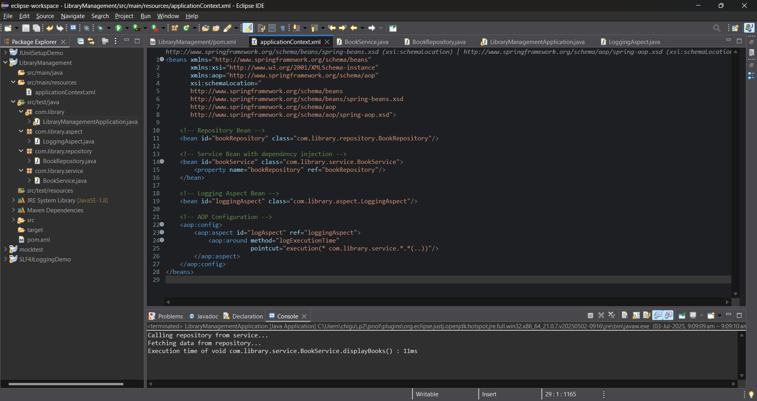

**Exercise 4: Creating and Configuring a Maven Project**

**Scenario:**

You need to set up a new Maven project for the library management application and add Spring dependencies.

**Steps:**

1. Create a New Maven Project
2. Add Spring Dependencies in pom.xml
3. Configure Maven Plugins

**Source Code:** pom.xml file:

<project xmlns="http://maven.apache.org/POM/4.0.0"

xmlns:xsi="http://www.w3.org/2001/XMLSchema-instance"

xsi:schemaLocation="http://maven.apache.org/POM/4.0.0

http://maven.apache.org/xsd/maven-4.0.0.xsd">

<modelVersion>4.0.0</modelVersion>

<groupId>com.library</groupId>

<artifactId>LibraryManagement</artifactId>

<version>0.0.1-SNAPSHOT</version>

<dependencies>

<!-- Spring Core -->

<dependency>

<groupId>org.springframework</groupId>

<artifactId>spring-context</artifactId>

<version>5.3.33</version>

</dependency>

<!-- Spring AOP -->

<dependency>

<groupId>org.springframework</groupId>

<artifactId>spring-aop</artifactId>

<version>5.3.33</version>

</dependency>

<!-- AspectJ Weaver -->

<dependency>

<groupId>org.aspectj</groupId>

<artifactId>aspectjweaver</artifactId>

<version>1.9.19</version>

</dependency>

</dependencies>

<build>

<plugins>

<!-- Compiler Plugin -->

<plugin>

<groupId>org.apache.maven.plugins</groupId>

<artifactId>maven-compiler-plugin</artifactId>

<version>3.8.1</version>

<configuration>

<source>1.8</source>

<target>1.8</target>

</configuration>

</plugin>

</plugins>

</build>

</project>